1. Configure Classic Load balancer.

---- created one classic load balancer

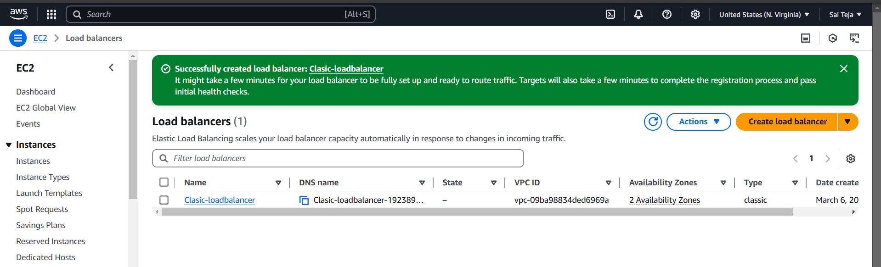

--- created 2 new ec2 instances

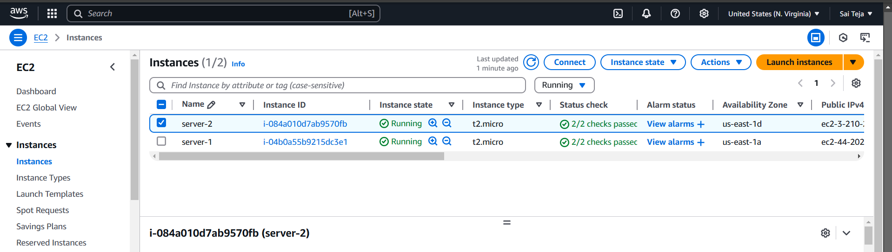

--- we can see your httpd is running successfully with instances Pub-IP

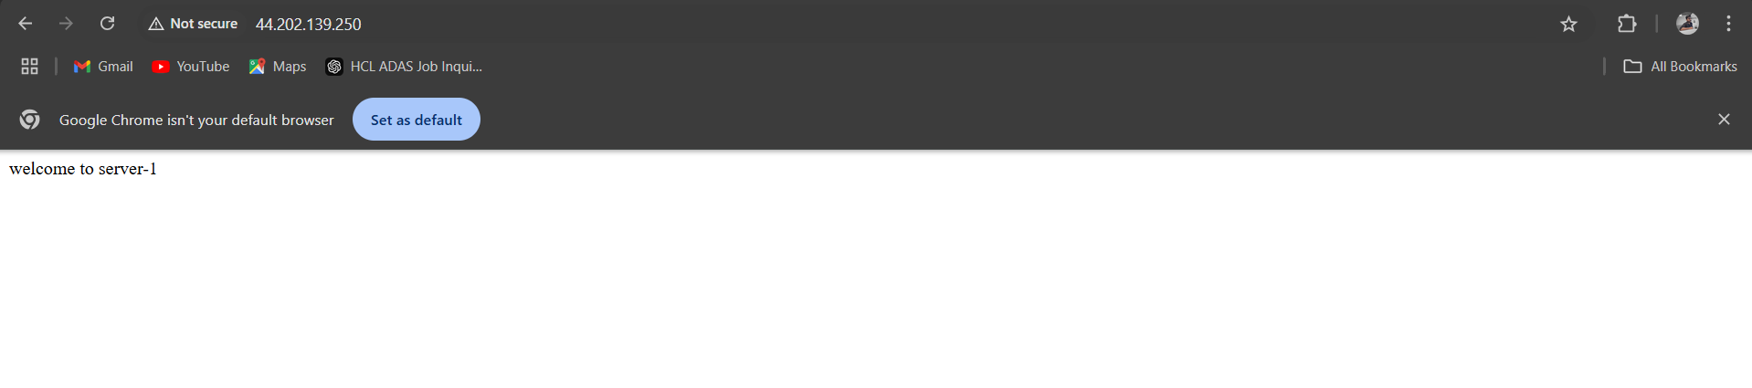

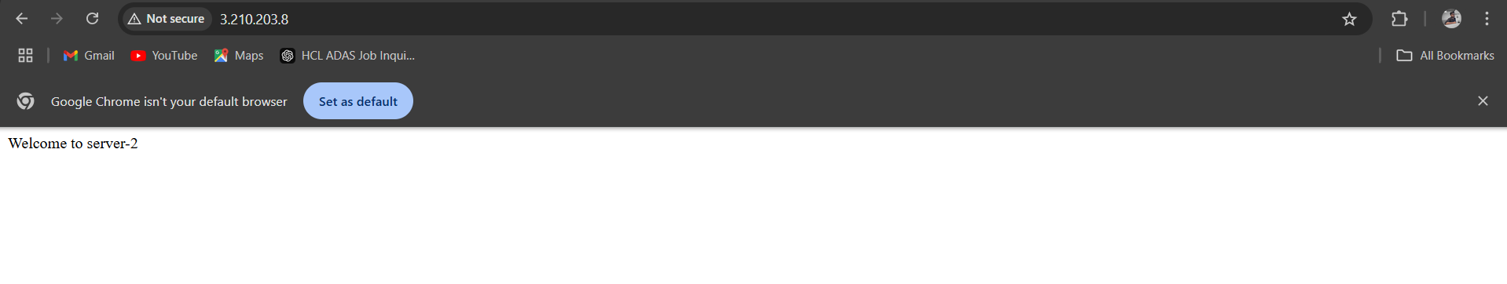

--- add the instances to the classic load balancer --- target instances—manage instances –select –save , we can also find the health check aswell

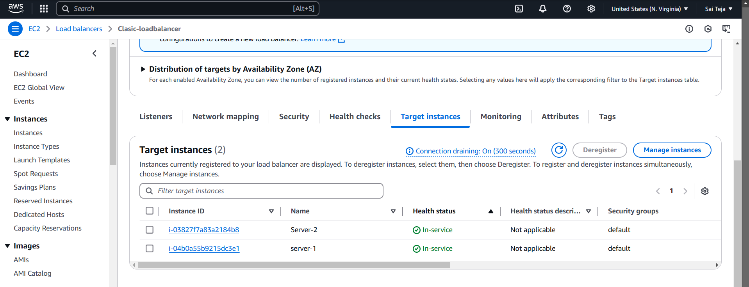

-----copy the URL of the load balancer and paste in the browser we can find the default deployed page of httpd using load balance

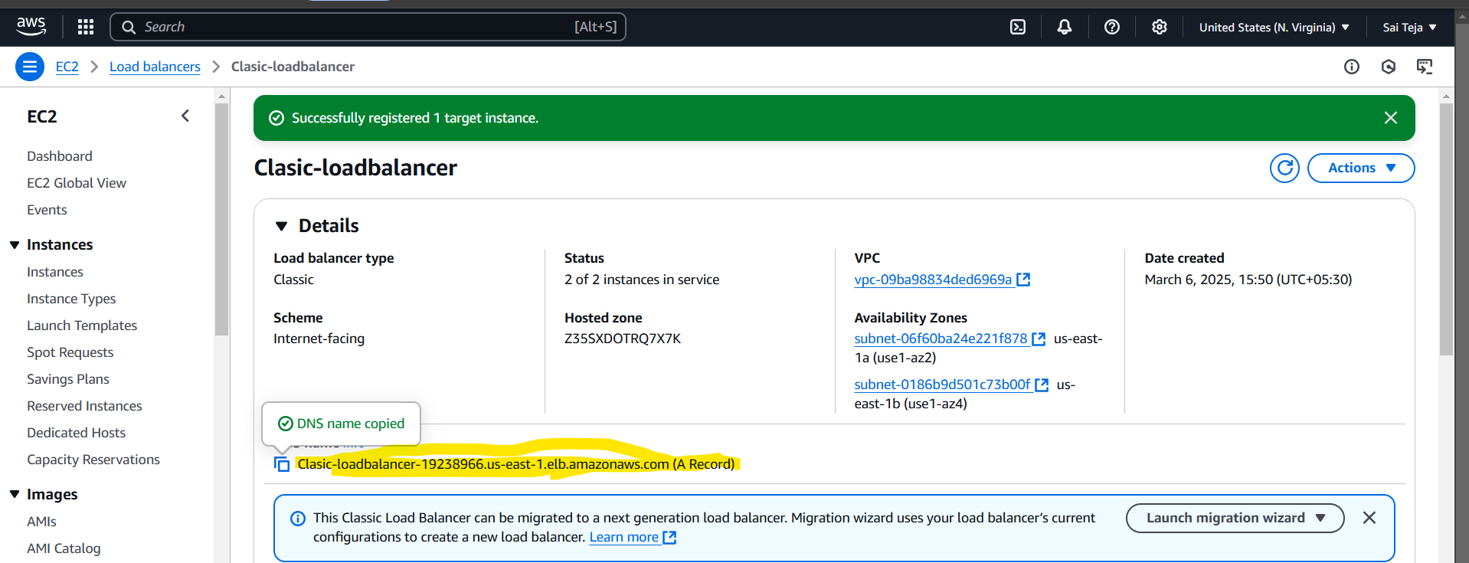

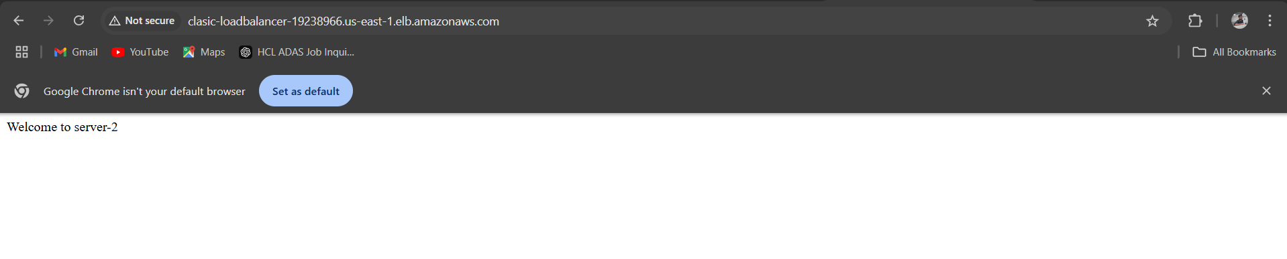

1. Configure Application Load balancer.

---create the target group and attach to the sever 1

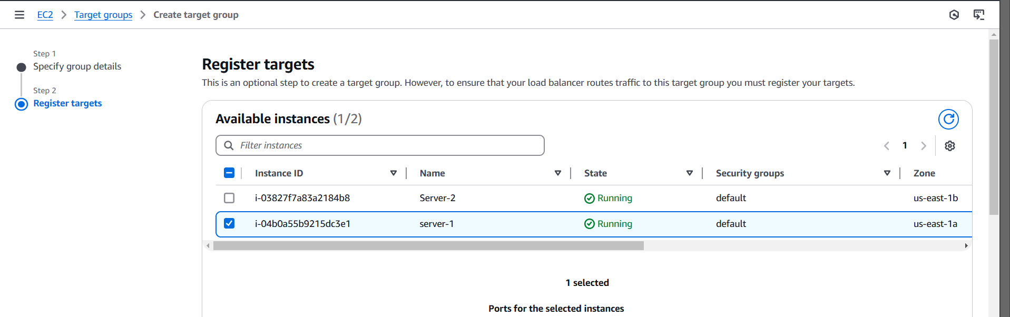

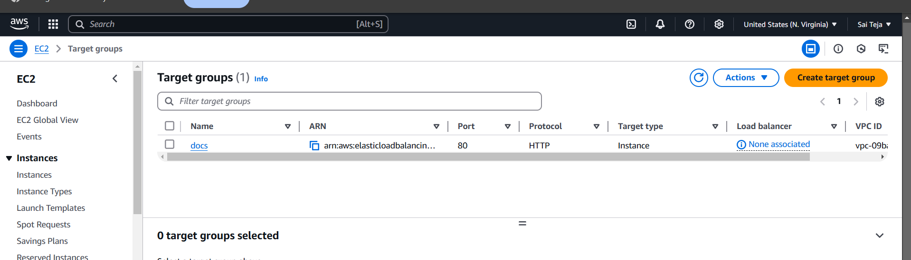

--- add the target group in the default while creating app loadbalancer and check for health status for attached ec2 instances (server 1)

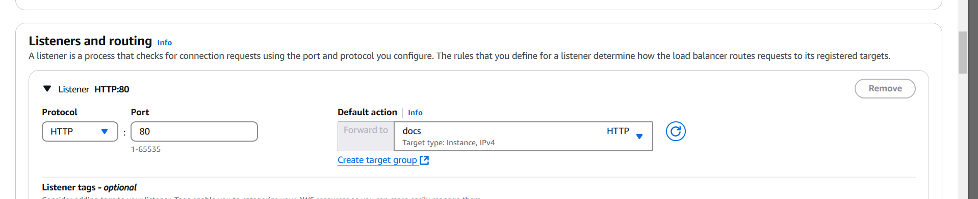

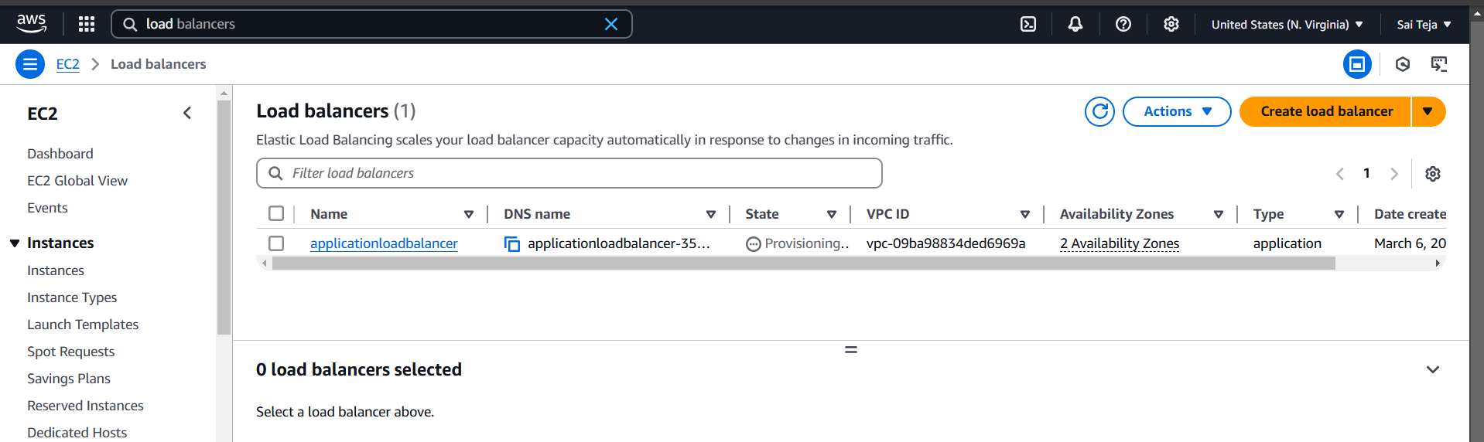

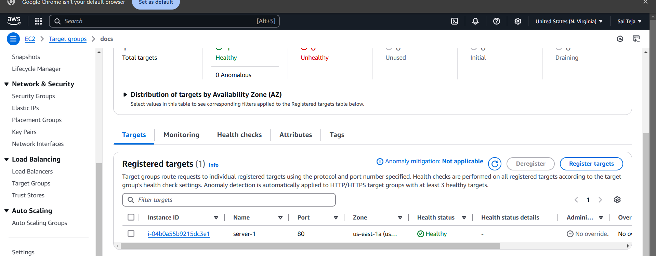

Copy the url of app loadbalancer and paste in the browser

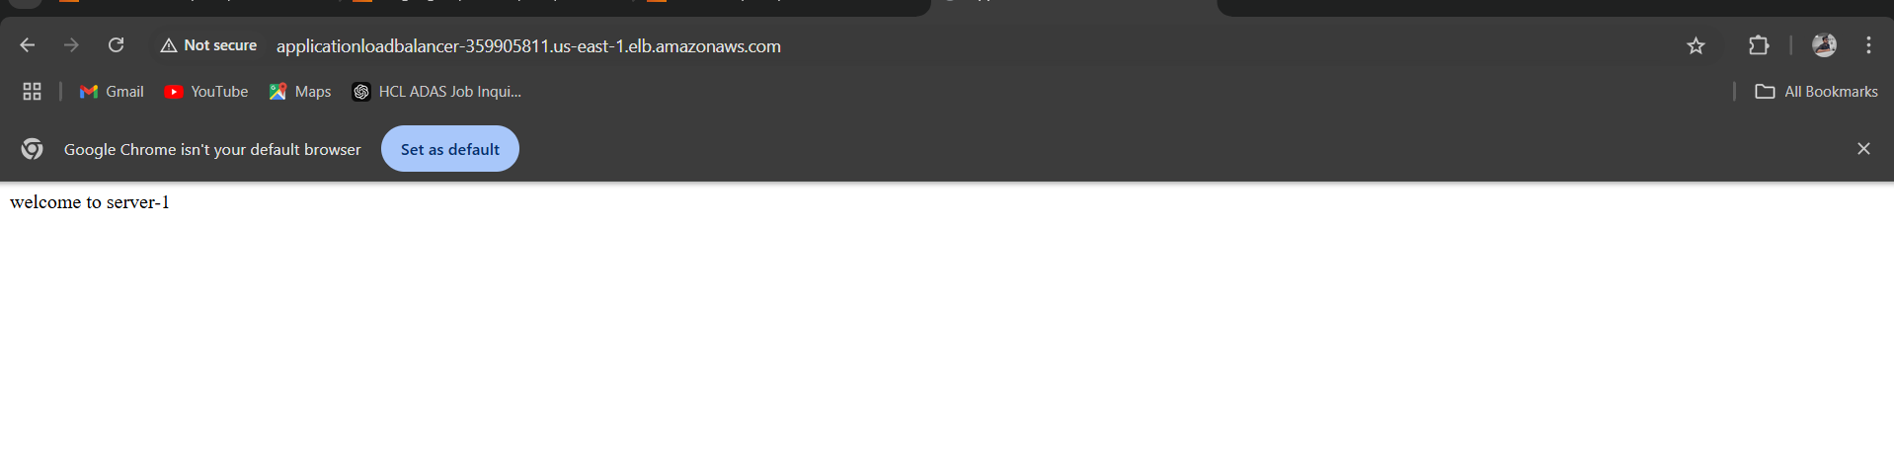

--- add rule that /docs using load balancer url with /docs I need to access for target grop docs

--- before that configure that in the server level

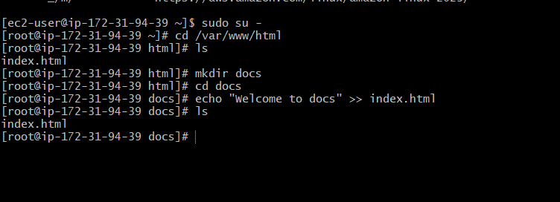

Go to load balancer – listener rule – click on rule – add rule – name(docs)- path - /docs* -done

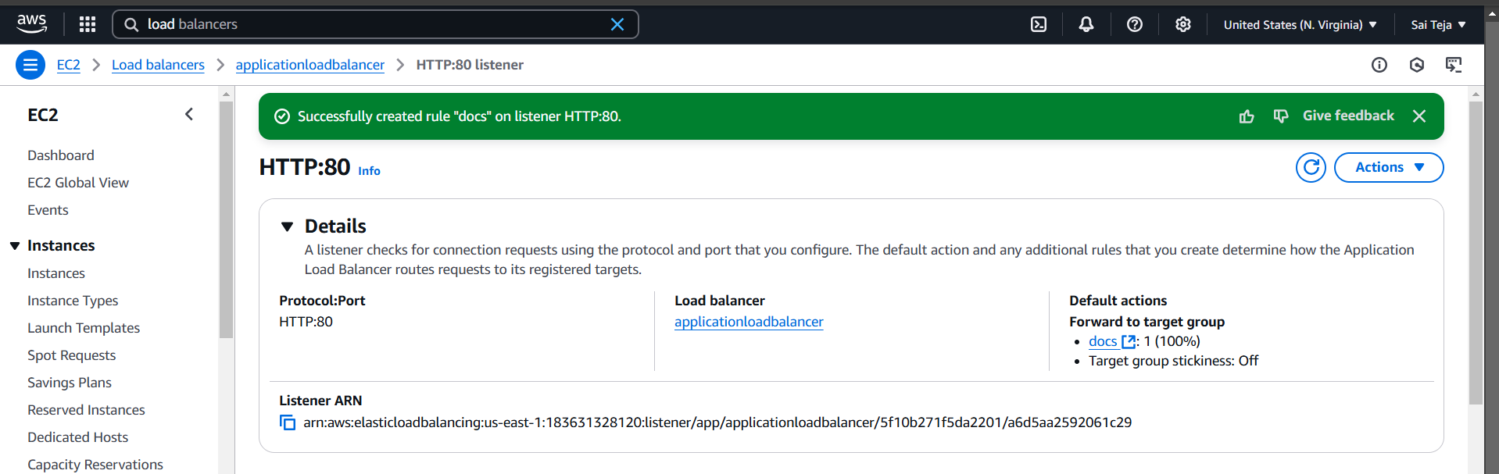

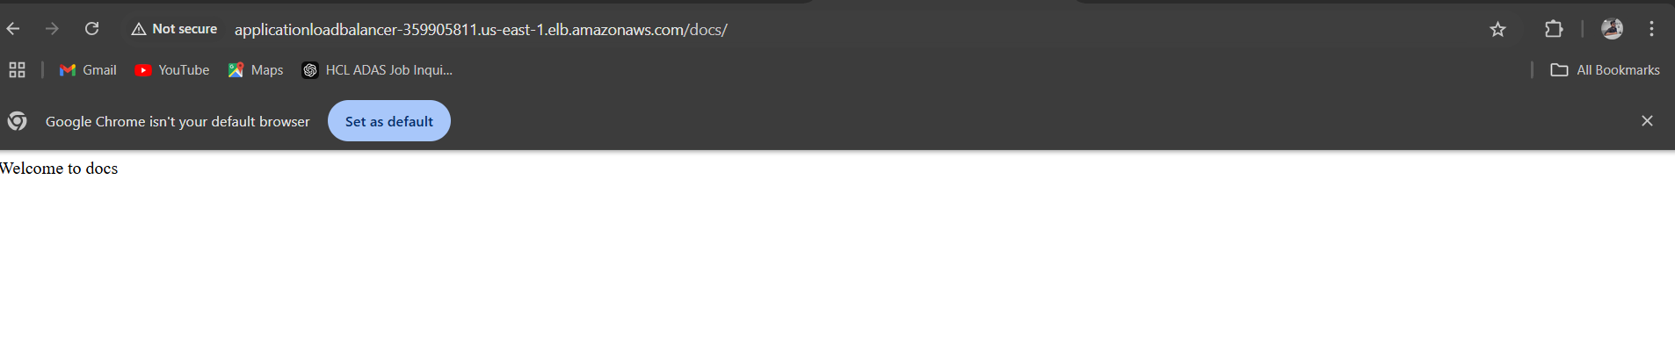

1. Attach SSL for application load balancer
2. Map Applciation load balancer to R53.

----create one SSL certificate

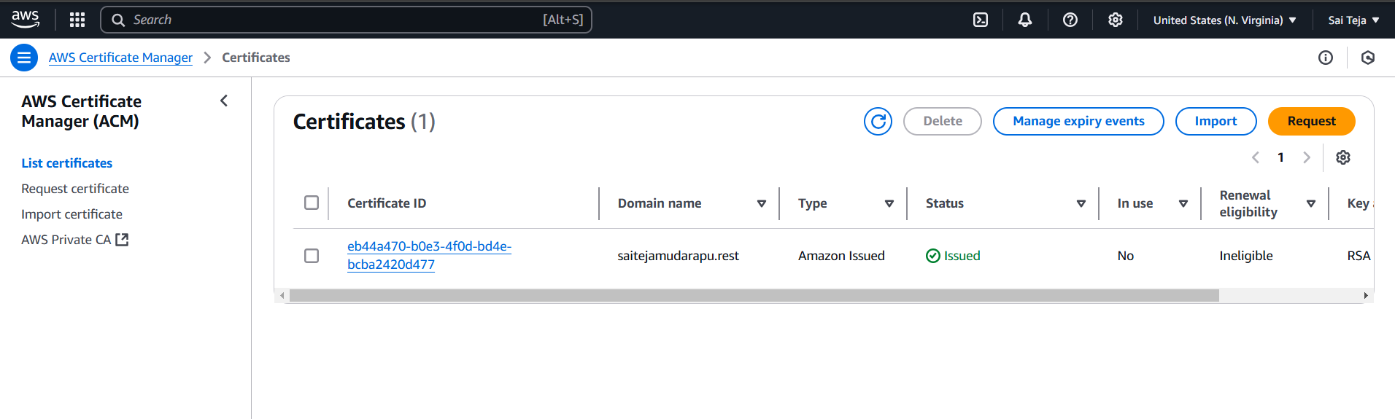

---- create hosted zone in R53

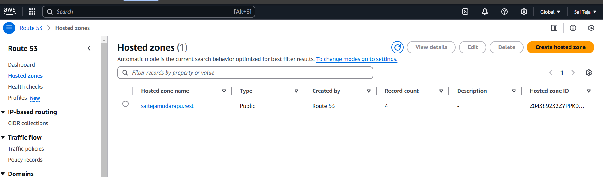

---- attach the ns to the domain

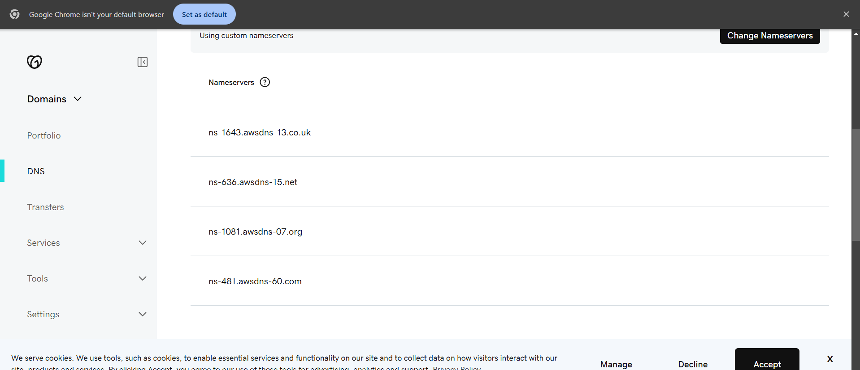

----- add CNAME to the records in R53

----- add Aname to the records in r53

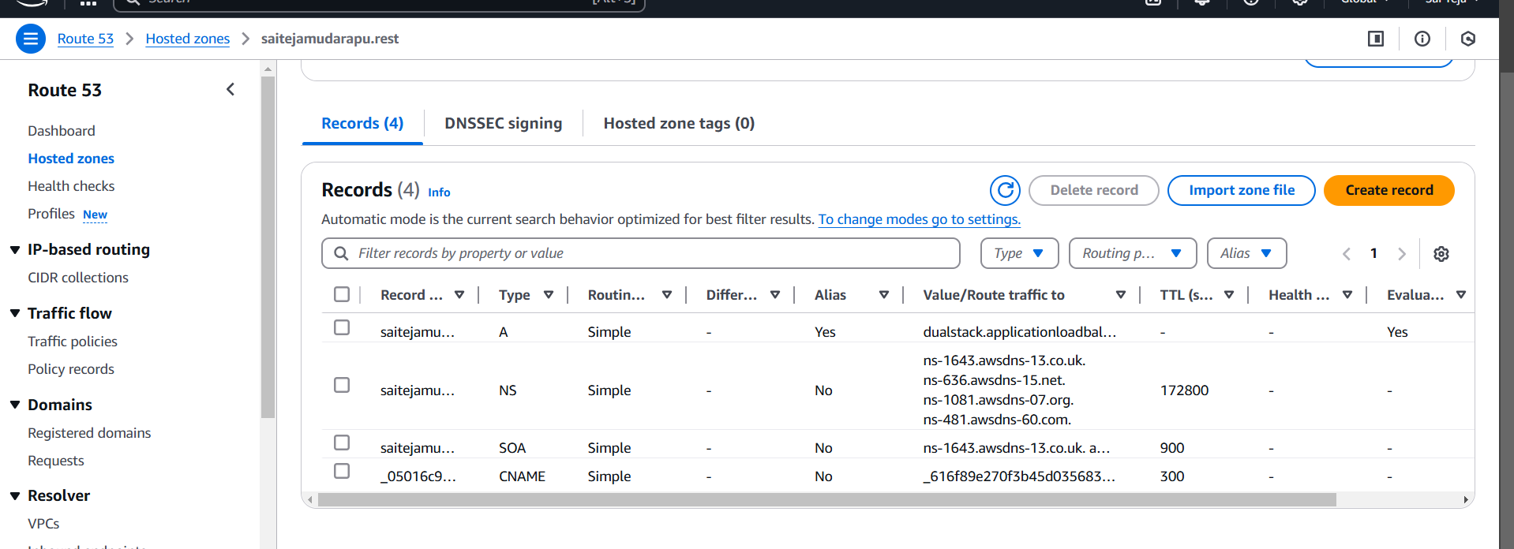

----- go to load balancer and add listener

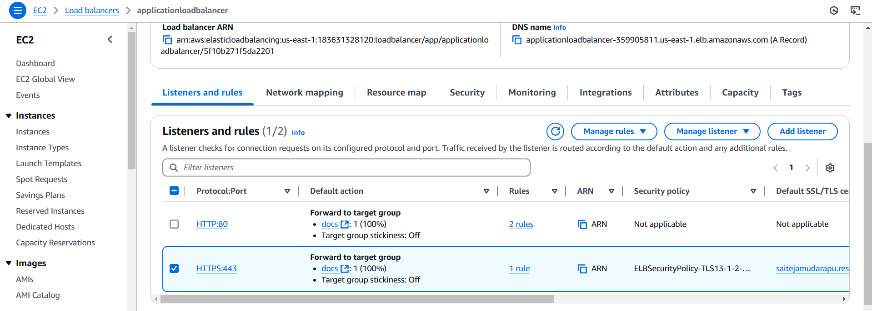

--- search with the domain name saitejamudarapu.rest

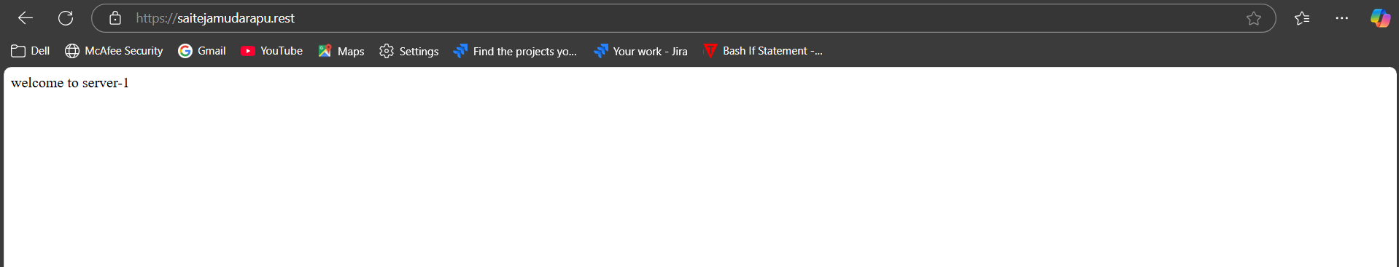

1. Push the application load balancer logs to s3.

---create one s3 bucket

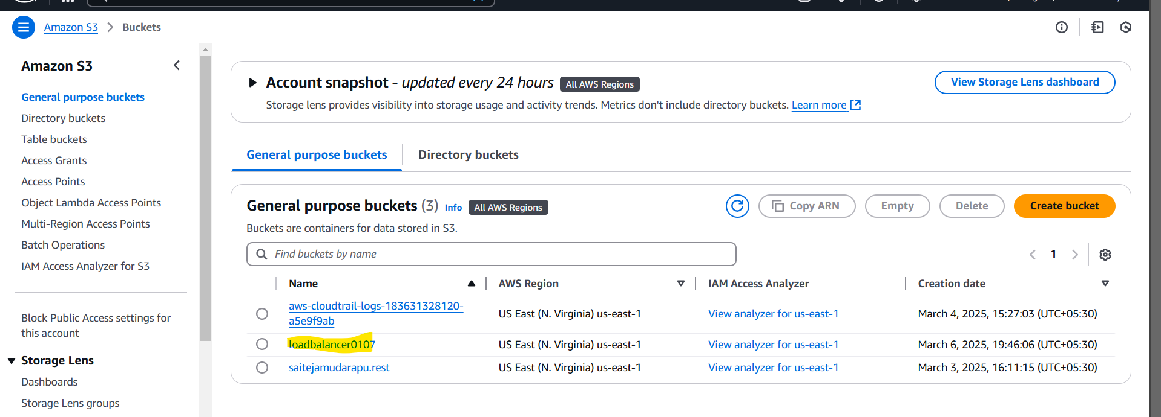

---- to go permission add policy in the bucket policy

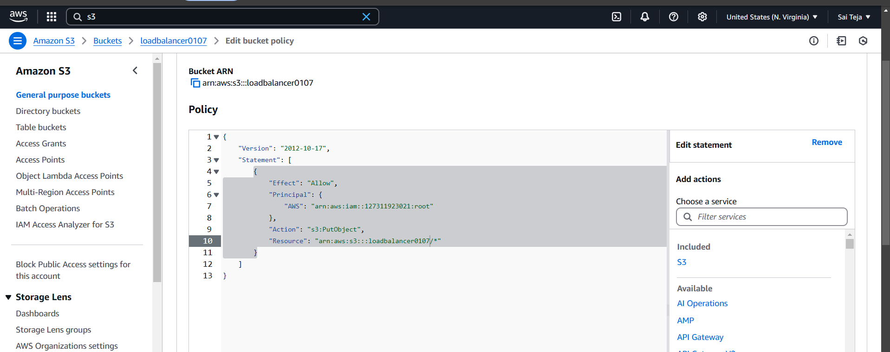

--- add s3 bucket to the apploadbalancer

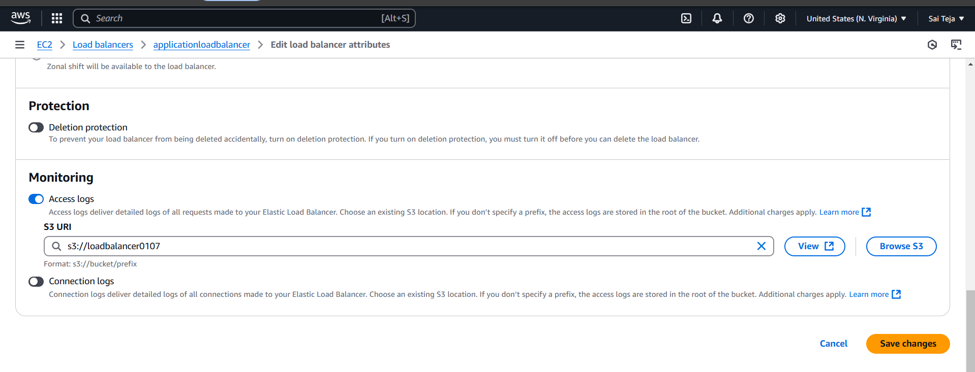

----go to s3 bucket and we can find log files

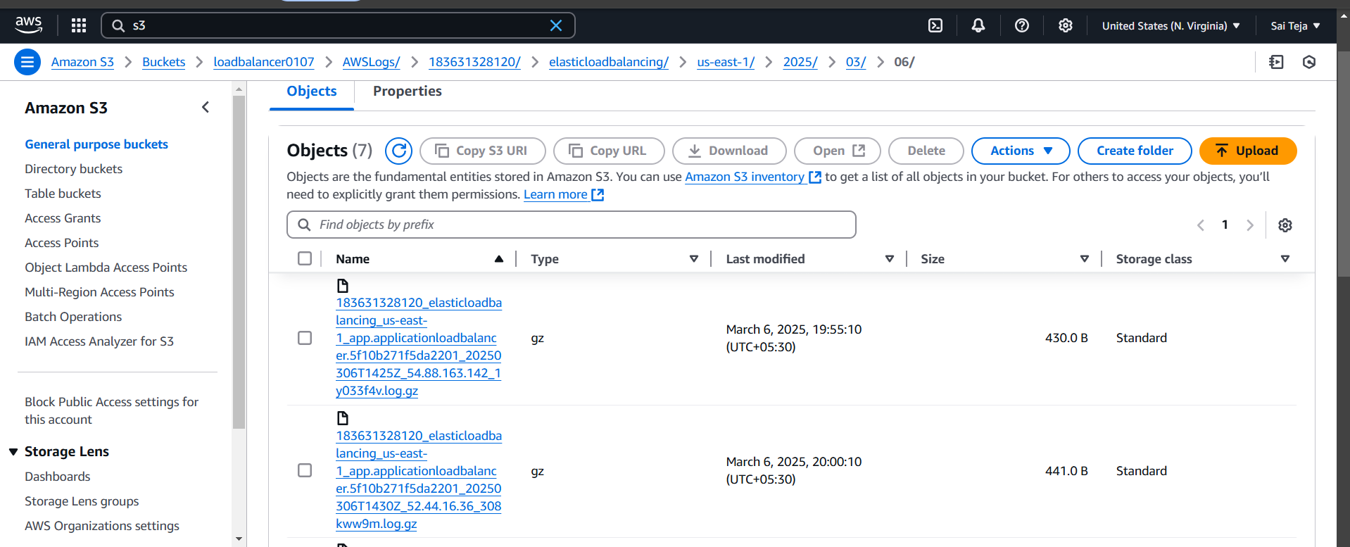

1. Configure Network Load balancer.

----- create 2 ec2 instances in 2 different sub nets

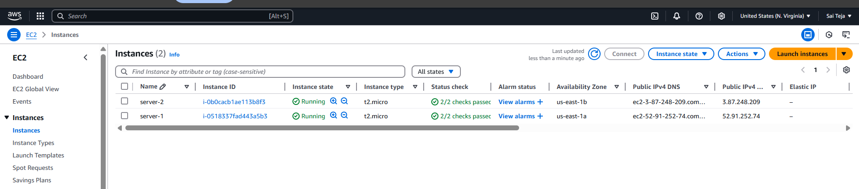

------ create 2 elastic ip

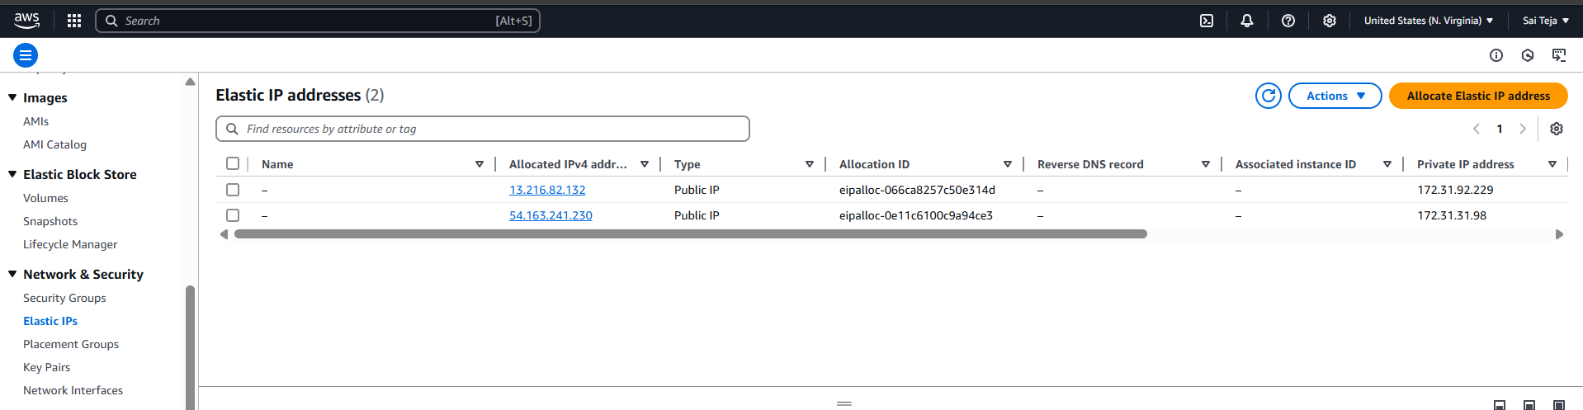

----- deploy index.html in 2 ec2 instances and start httpd

------ create one network loadbalancer and create and attach target group to the load balancer

------- attach 2 ec2 instances in target group

------- while creating load balancer attach elastic ip as well

------ when we browse with load balancer dns url we find your index.html

------- we can also check with your elastic ip also



 